Lab 4 Tasks - Explanations

# Task 1: LUHN Algorithm

This program checks whether a given card number is valid using the LUHN algorithm.

Steps:  
1. Remove spaces from the input number.  
2. Reverse the digits.  
3. Starting from the second digit (from the right), double every second digit.  
4. If the result is greater than 9, subtract 9 from it.  
5. Add all digits together.  
6. If the total is divisible by 10, the card number is valid.  
**OUTPUT:**

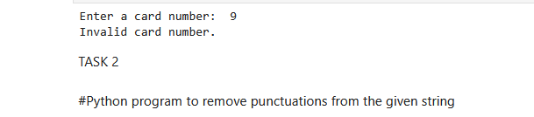

# Task 2: Remove Punctuations from String

This program removes all punctuation marks from a string.

Steps:  
1. Define a string of all punctuation characters.  
2. Loop through each character of the input string.  
3. If the character is not a punctuation, add it to the result.  
4. Return and print the cleaned string.  
**OUTPUT:**

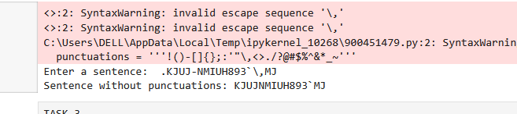

# Task 3: Sort Sentence in Alphabetical Order

This program sorts the words in a sentence in alphabetical order.

Steps:  
1. Split the sentence into words using split().  
2. Sort the list of words using sort().  
3. Join the sorted words back into a sentence using join().

**OUTPUT:**  
